The Top 10 Countries for LEED in 2023 demonstrate that the green building movement is truly global

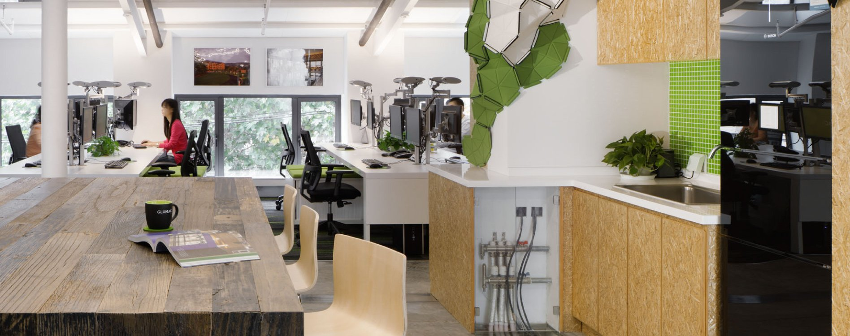

Deisy Verdinez
Feb. 06, 2024
Feature image: The LEED Platinum Glumac Shanghai Office T1. Photo credit: © Glumac.
USGBC recently announced the Top 10 Countries and Regions for LEED in 2023. The annual ranking highlights countries and regions outside the United States that are making significant strides in sustainable building design, construction and operations. The Top 10 report highlights the remarkable progress of reducing greenhouse gas emissions, health impacts and operating costs in buildings around the world.
Once again, China topped the list in 2023, with 1,563 LEED projects certified, encompassing more than 264 million square feet (24.5 million gross square meters). Canada ranked second with 280 projects, representing 85 million gross square feet (nearly 8 million gross square meters). India rounded out the top three with more than 77 million gross square feet (7.2 million gross square meters).
Turkey broke into the rankings in fourth place with 36 LEED-certified projects encompassing more than 31 million certified square feet (2.9 million gross square meters). Among the country's highest-profile projects is the Okmeydani Training and Research Hospital in Istanbul.
The role of buildings in addressing climate change continues to take center stage. During COP 28 last year in Dubai, more than two dozen countries, including the United States, joined the Buildings Breakthrough. The partnership commits to the vision that resilient buildings with near-zero emissions will be the “new normal” by 2030.
Tools like LEED can help building owners and managers meet their sustainability goals and reduce their environmental impact.
The Top 10 report is used to develop the list that ranks countries based on total LEED-certified space between Jan. 1 and Dec. 31, 2023. The U.S. is not included in the ranking, but remains the world’s largest market for LEED, with more than 556 million square feet certified in 2023.
In 2023, there were more than 6,000 LEED commercial projects worldwide.

